**Assignment**

**CSA0805 – Python Programming**

|  |  |
| --- | --- |
| **Register Number** | **192324200** |
| **Name** | **SANTHOSH S** |

**Title:**

**Markdown File Viewer**

**Problem Statement:**

**Create a Python program that displays Markdown files in a user-friendly interface with rendered HTML output, supporting navigation, zooming, and syntax highlighting for code blocks.**

**Code: Python Code;**

**import tkinter as tk**

**from tkinter import filedialog**

**from tkinter import ttk**

**import markdown**

**import pygments**

**from pygments.formatters import HtmlFormatter**

**from pygments.lexers import get_lexer_by_name**

**from pygments.util import ClassNotFound**

**from bs4 import BeautifulSoup**

**from tkhtmlview import HTMLLabel**

**class MarkdownViewer(tk.Tk):**

**def __init__(self):**

**super().__init__()**

**self.title("Markdown File Viewer")**

**self.geometry("800x600")**

**self.create_widgets()**

**def create_widgets(self):**

**# Create menu**

**menu_bar = tk.Menu(self)**

**self.config(menu=menu_bar)**

**file_menu = tk.Menu(menu_bar, tearoff=0)**

**menu_bar.add_cascade(label="File", menu=file_menu)**

**file_menu.add_command(label="Open", command=self.open_file)**

**# Create a frame for the HTML content**

**self.html_frame = HTMLLabel(self)**

**self.html_frame.pack(fill="both", expand=True)**

**# Create a text widget for zoom control**

**self.zoom_slider = ttk.Scale(self, from_=0.5, to=2.0, orient='horizontal', command=self.zoom)**

**self.zoom_slider.set(1.0)**

**self.zoom_slider.pack(fill='x')**

**def open_file(self):**

**file_path = filedialog.askopenfilename(filetypes=[("Markdown Files", "*.md")])**

**if file_path:**

**with open(file_path, "r") as file:**

**markdown_text = file.read()**

**html_content = self.convert_markdown_to_html(markdown_text)**

**self.html_frame.set_html(html_content)**

**def convert_markdown_to_html(self, markdown_text):**

**# Convert Markdown to HTML**

**html_content = markdown.markdown(markdown_text, extensions=['fenced_code'])**

**# Apply syntax highlighting**

**soup = BeautifulSoup(html_content, 'html.parser')**

**for code_block in soup.find_all('code'):**

**lexer_name = code_block.get('class', [''])[0]**

**try:**

**lexer = get_lexer_by_name(lexer_name, stripall=True)**

**except ClassNotFound:**

**lexer = get_lexer_by_name('text', stripall=True)**

**formatter = HtmlFormatter(style='colorful')**

**highlighted_code = pygments.highlight(code_block.string, lexer, formatter)**

**code_block.replace_with(BeautifulSoup(highlighted_code, 'html.parser'))**

**return str(soup)**

**def zoom(self, scale_value):**

**scale = float(scale_value)**

**style = f"body {{ font-size: {scale}em; }}"**

**self.html_frame.set_html(f"<style>{style}</style>{self.html_frame.get_html()}")**

**if __name__ == "__main__":**

**app = MarkdownViewer()**

**app.mainloop()**

**Markdown file viewer code:**

**# Sample Markdown Document**

**Welcome to the Markdown sample document. Below are some of the features you can use:**

**## Headings**

**### Heading 3**

**#### Heading 4**

**## Formatting**

**- **Bold text** can be created with `**double asterisks**` or `__double underscores__`.**

**- *Italic text* can be created with `*single asterisk*` or `_single underscore_`.**

**## Lists**

**### Unordered List**

**- Item 1**

**- Item 2**

**- Subitem 2.1**

**- Subitem 2.2**

**### Ordered List**

**1. First item**

**2. Second item**

**3. Third item**

**## Links and Images**

**- [Python Programming for List Implementation](https://github.com/Santhoshyuvesh/PYTHON---PROGRAMMING-FOR-LIST-IMPLEMENTATION-CSA0814)**

**- ![GitHub Logo](https://github.githubassets.com/images/modules/logos_page/GitHub-Mark.png)**

**## Code**

**### Inline Code**

**Use backticks for `inline code`.**

**### Code Block**

**```python**

**def hello_world():**

**print("Hello, World!")**

**Output Screen Shots:**

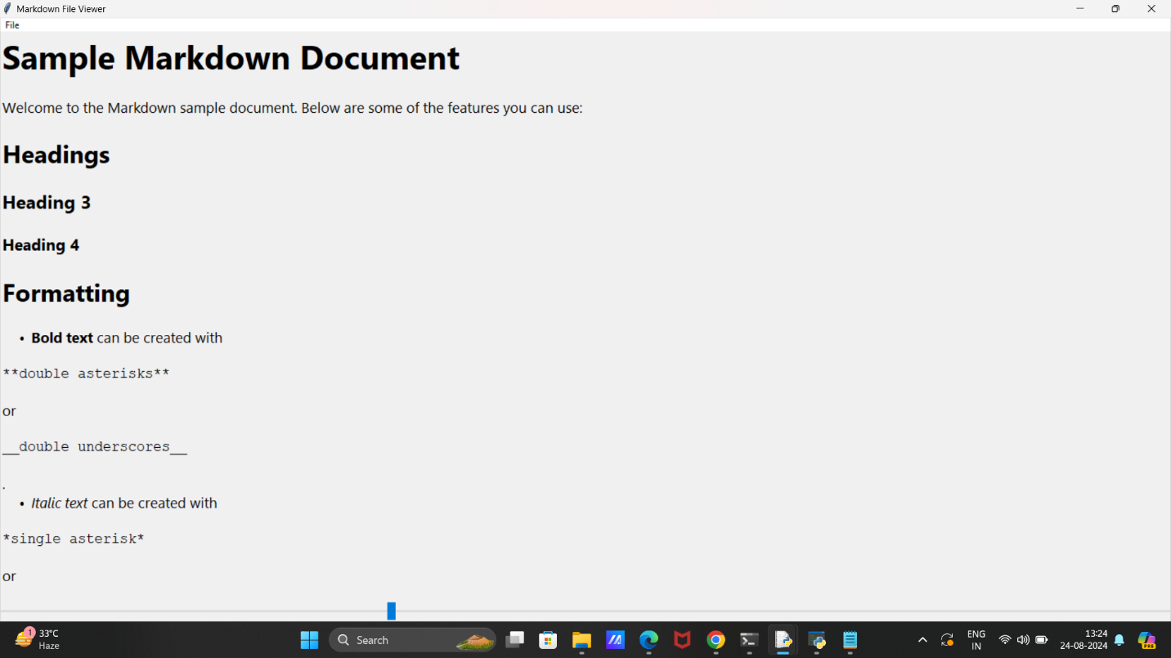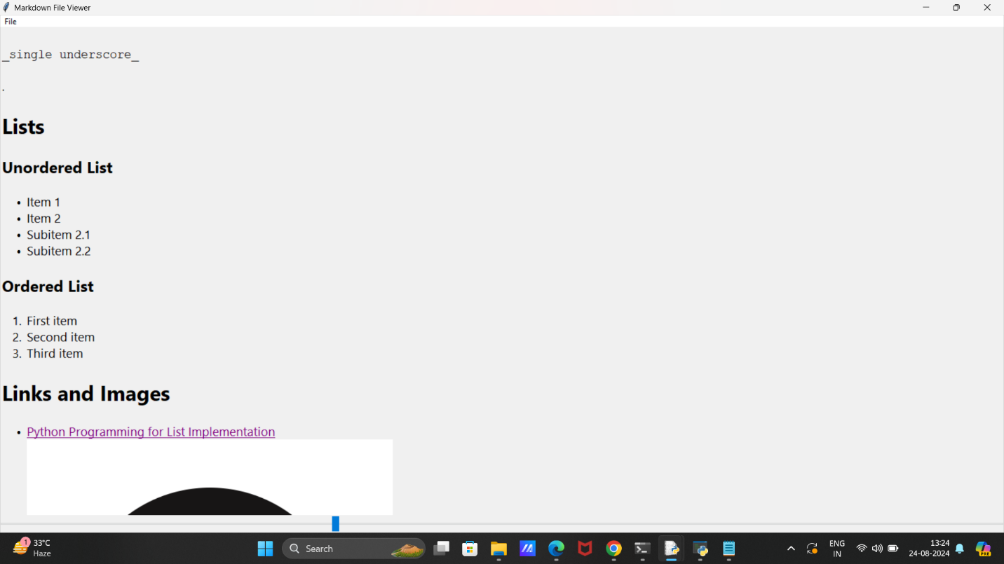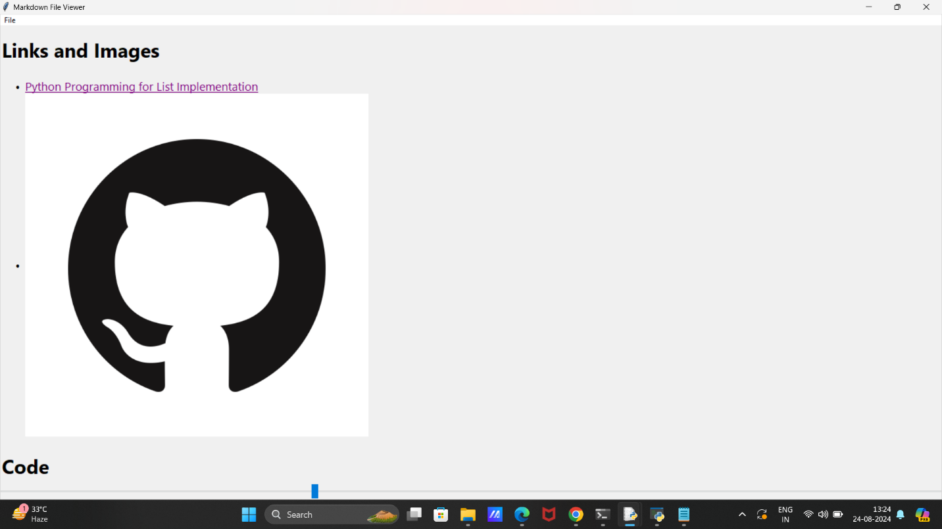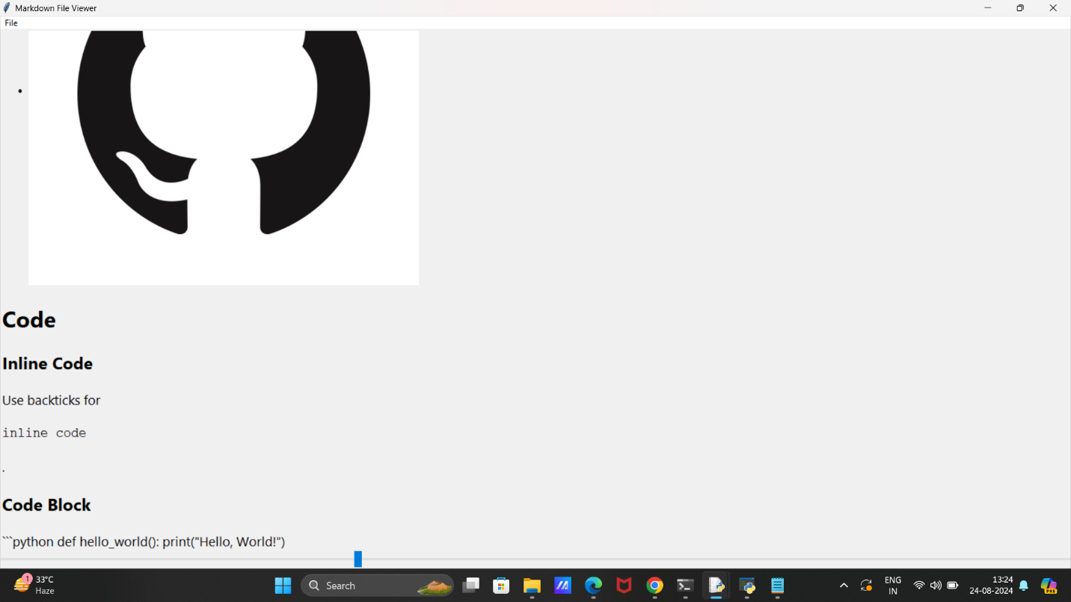

**Conclusion:**

**Markdown files are plain text files formatted with Markdown syntax, which is a lightweight markup language. They use simple symbols to format text, making it easy to create well-structured documents without complex formatting. Markdown files typically have a .md or .markdown extension.**

**Common Markdown Syntax**

* **Headings: # Heading 1, ## Heading 2, ### Heading 3**
* **Bold text: **bold** or __bold__**
* **Italic text: *italic* or _italic_**
* **Lists:**
  + **Unordered: - Item or * Item**
  + **Ordered: 1. Item**
* **Links: [Link text](URL)**
* **Images: ![Alt text](URL)**
* **Code: `inline code` or code block**

**Markdown is often used for README files, documentation, and writing content for blogs or websites due to its simplicity and readability.**